Natural language translation engine for announcements and information dissemination at stations

CONTENT | PAGE NO
Abstract
1.INTRODUCTION
1.1 Motivation
1.2 Problem Statement
1.3 Objective of the Project
1.4 Scope
1.5 Project Introduction
2.LITERATURE SURVEY
2.1 Related Work
3. SYSTEM ANALYSIS
3.1 Existing System
3.2 Disadvantages
3.3 Proposed System
3.4 Advantages
3.5 work Flow of Proposed system
4. REQUIREMENT ANALYSIS
4.1 Function and non-functional requirements
4.2 Hardware Requirements
4.3 Software Requirements
4.4 Architecture
5. SYSTEM DESIGN
5.1 Introduction of Input design
5.2 UML Diagram (class, use case, sequence, collaborative, deployment, activity, ER diagram and Component diagram)
5.3 Data Flow Diagram
6. IMPLEMENTATION AND RESULTS
6.1 Modules
6.2 Output Screens
- SYSTEM STUDY AND TESTING
7.1 Feasibility study
7.2 Types of test & Test Cases
- 8. CONCLUSION
9. FUTURE ENHANCEMENT
10. REFERENCES

ABSTRACT:
This project integrates the Google Text-to-Speech (gTTS) Python library to develop a multilingual information dissemination system for Indian railway stations. gTTS, renowned for its natural-sounding speech and extensive language support, including various Indian dialects, plays a key role in converting text to audible announcements. The system is designed to seamlessly translate written information into speech, enhancing accessibility and convenience for passengers. It incorporates real-time text-to-speech conversion, ensuring dynamic and accurate information delivery. Essential for stations, this solution addresses the need for clear communication in noisy environments and is adaptable for mobile platforms, making it a robust tool for modern, efficient railway operations.
Keywords: gTTS, Multilingual, Indian Railways, Text-to-Speech, Information Dissemination, Real-Time Conversion, Speech Synthesis, Python, Accessibility, Noisy Environments, Mobile Integration.

1. INTRODUCTION
1.1 Motivation:
The motivation behind "Natural Language Translation Engine for Announcements and Information Dissemination at Stations" stems from the critical need to enhance passenger experience in Indian railways. By leveraging the gTTS library for multilingual speech synthesis, this project aims to bridge communication gaps in noisy environments, ensuring accessible, dynamic, and accurate information delivery, thus significantly improving efficiency and convenience in railway operations.
1.2 Problem Statement:
In Indian railway stations, passengers often face challenges in receiving clear, timely information due to language barriers and noisy environments. The existing systems struggle to cater to the diverse linguistic landscape and dynamic nature of railway operations. This project addresses the need for a versatile, real-time information dissemination system that leverages the gTTS library for natural-sounding, multilingual announcements, enhancing accessibility and passenger experience.
1.3 Objective of the Project:
The objective of this project is to develop a sophisticated natural language translation engine utilizing the Google Text-to-Speech (gTTS) Python library, aimed at revolutionizing announcements and information dissemination across Indian railway stations. By facilitating multilingual speech synthesis, the system seeks to enhance passenger experience through real-time, accessible, and clear communication, particularly in noisy environments, thereby improving operational efficiency and inclusivity in India's vast railway network.

1.4 Scope:
The scope of this project encompasses the development of a multilingual text-to-speech system for Indian railway stations, utilizing the gTTS Python library for real-time information conversion into audible announcements. It focuses on enhancing passenger accessibility and convenience by supporting various Indian dialects, ensuring clear communication in noisy settings, and offering mobile platform integration for improved railway operational efficiency.
1.5 Project Introduction:
In the bustling environs of Indian railway stations, where the confluence of diverse languages and dialects presents a unique challenge to effective communication, the need for a robust, multilingual information dissemination system is paramount. This project introduces a cutting-edge solution: a Natural Language Translation Engine for Announcements and Information Dissemination at Stations, leveraging the capabilities of the Google Text-to-Speech (gTTS) Python library. Known for its natural-sounding speech synthesis and extensive support for a wide array of languages, including a multitude of Indian dialects, gTTS stands at the core of this innovative system. Designed to bridge the communication gap, this system adeptly converts textual information into audible announcements, thereby enhancing accessibility and convenience for passengers. Its cornerstone is the real-time text-to-speech conversion feature, which ensures the delivery of dynamic and accurate information, vital for the ever-changing schedules and updates typical of railway operations. This project is not just about addressing the need for clear communication amidst the cacophony of noisy environments; it's also about inclusivity. By incorporating speech synthesis that accommodates various Indian languages, the system ensures that information is accessible to a broader audience, making travel more seamless and less daunting for passengers from different linguistic backgrounds. Moreover, with its adaptability for mobile platforms, the solution proposed herein transcends traditional announcement systems, offering a versatile tool for modern, efficient railway operations. This initiative not only enhances passenger experience but also sets a new standard for public transportation systems in multilingual and multicultural contexts.

2. LITERATURE SURVEY
2.1 Related Work:
[1] Bar-Hillel, Y. (1951). The present state of research on mechanical translation. American Documentation 2 (4): 229-237.
Bar-Hillel's (1951) article explores the burgeoning field of mechanical translation (MT), driven by both intellectual curiosity and practical necessity. With a focus on translating foreign language publications in science, finance, and diplomacy, the scarcity of bilingual experts poses significant challenges and costs to research. Moreover, there's a pressing need for high-speed, albeit potentially lower accuracy, scanning of vast printed materials for various purposes. Bar-Hillel suggests that advancements in MT could address these challenges, offering valuable insights into linguistic communication while facilitating efficient translation and scanning processes.
[2] Bar-Hillel, Y. (1960). The present status of automatic translation of languages. Advances in Computers 1: 91-163.
the-art for spatio-temporal crime hotspot detection and prediction techniques by conducting a systematic
literature review (SLR). The authors were unable to ﬁnd a comprehensive study on crime hotspot detection
and prediction while conducting this SLR. Therefore, to the best of author’s knowledge, this study is the
premier attempt to critically analyze the existing literature along with presenting potential challenges faced
by current crime hotspot detection and prediction systems. The SLR is conducted by thoroughly consulting
top ﬁve scientiﬁc databases (such as IEEE, Science Direct, Springer, Scopus, and ACM), and synthesized
49 different studies on crime hotspot detection and prediction after critical review. This study unfolds the
following major aspects: 1) the impact of data mining and machine learning approaches, especially clustering
techniques in crime hotspot detection; 2) the utility of time series analysis techniques and deep learning
techniques in crime trend prediction; 3) the inclusion of spatial and temporal information in crime datasets
making the crime prediction systems more accurate and reliable; 4) the potential challenges faced by the
state-of-the-art techniques and the future research directions. Moreover, the SLR aims to provide a core
foundation for the research on spatio-temporal crime prediction applications while highlighting several
challenges related to the accuracy of crime hotspot detection and prediction applications.
In his 1960 paper, "The Present Status of Automatic Translation of Languages," Bar-Hillel provides an overview of the burgeoning field of machine translation (MT). He notes the significant investment in MT research, particularly in the United States and Russia, with estimates suggesting substantial funding and personnel dedicated to the endeavor. Bar-Hillel also mentions the presence of research centers in England and Italy, highlighting the global interest in MT. Overall, the abstract underscores the growing importance and international engagement in the development of automatic language translation systems.
[3] Birch, A., Osborne, M. (2011). Reordering metrics for MT.
The paper "Reordering Metrics for MT" by Birch and Osborne (2011) introduces the LRscore, a novel metric designed to address the challenge of accurately modeling word order differences in statistical machine translation (MT). Unlike existing metrics which primarily focus on lexical item matching, the LRscore explicitly evaluates word order quality using permutation distance metrics. The study demonstrates that the LRscore aligns more closely with human judgments compared to other metrics like BLEU score. Additionally, training translation model parameters with LRscore results in preferred human-readable translations without sacrificing BLEU scores.
[4] Denkowski, M., Lavie, A, Lacruz, I., Dyer, C. (2014). Real time adaptive machine translation for post-editing with cdec and TransCenter. In Proceedings of the EACL 2014 Workshop on Humans and Computer-assisted Translation.
The abstract outlines the development of cdec Realtime, an adaptable machine translation (MT) framework, and TransCenter, a web-based translation interface. These tools facilitate the utilization of MT output as a foundation for human translation, with cdec Realtime learning from post-editor feedback. TransCenter enables users to connect to Realtime systems and logs post-editing activity, aiding in the analysis of human translator productivity. The combination of these tools allows for the streamlined deployment of MT systems tailored for post-editing. Additionally, both tools and post-editing data from validation experiments are available under an open-source license.
[5] Green, S., Wang, S., Chuang, J., Heer, J. Schuster, S., Manning, C. D. (2014). Human effort and machine learnability in computer aided translation. In Proceedings of EMNLP, 1225-1236.
The study investigates the interplay between human effort and machine learnability in computer-aided translation, emphasizing the integration of frontend interfaces and backend translation processes. Contrasting postediting and interactive machine translation modes, the research introduces a new translator interface and modifications to a phrase-based MT system. Evaluation with professional translators reveals that while postediting is faster, interactive translation yields higher quality results after re-tuning the MT system. Direct tuning to Human Translation Error Rate (HTER) results in significant improvements in subsequent machine output, indicating the efficacy of interactive translation methods.
[6] Grudin, J. (2012). A moving target—the evolution of human-computer interaction. In Jacko, J. A. (Ed.), Human-Computer Interaction Handbook: Fundamentals, Evolving Technologies, and Emerging Applications (3rd edition), xxvii-lxi. CRC Press.
The abstract of Grudin's chapter in the Human-Computer Interaction Handbook outlines the dynamic nature of human-computer interaction (HCI) evolution. It emphasizes the constant change and development within HCI, portraying it as a "moving target." Grudin likely discusses the fundamental shifts, evolving technologies, and emerging applications shaping HCI. Through this examination, he likely highlights the challenges and opportunities inherent in navigating this evolving landscape. The chapter promises insights into the past, present, and future of HCI, providing a comprehensive understanding of this interdisciplinary field.

3. SYSTEM ANALYSIS
3.1 Existing Method:
The existing system for railway information dissemination, relying on older libraries, offers basic multilingual support primarily for major Indian languages. It utilizes traditional text-to-speech (TTS) engines and basic natural language processing (NLP) techniques. The system is capable of scripted station announcements and responses over IVRS, but lacks real-time adaptability and the nuanced understanding of modern NLP tools. Its speech synthesis, while functional, does not match the natural quality of newer technologies like gTTS. Limited by older frameworks, the system faces challenges in noise reduction, dynamic content generation, and integration with contemporary mobile and web platforms, highlighting the need for an upgrade to more advanced solutions.
3.2 Disadvantages:
1. Limited multilingual support, primarily for major Indian languages, restricts accessibility for diverse linguistic communities.
2. Outdated text-to-speech (TTS) engines result in unnatural sounding announcements, diminishing user experience.
3. Lack of real-time adaptability hinders the system's ability to provide timely and relevant information.
4. Inadequate noise reduction capabilities diminish the clarity of announcements, affecting communication in busy station environments.
5. Integration challenges with modern mobile and web platforms limit the system's accessibility and usability for passengers.

3.3 PROPOSED METHOD
The proposed system leverages advanced technologies like the Google Text-to-Speech (gTTS) Python library to revolutionize information dissemination in Indian railway stations. This solution offers extensive multilingual support, including regional Indian languages and potential for foreign language expansion. It integrates real-time text-to-speech conversion with sophisticated natural language processing (NLP) capabilities, facilitating dynamic, accurate, and natural-sounding announcements. Designed to operate effectively in noisy environments, the system includes noise reduction techniques and is optimized for mobile and web platforms, ensuring accessible and efficient communication. This modern approach significantly enhances passenger experience through timely, clear, and personalized information delivery in a variety of languages.
3.4 Advantages:
1. Enhanced Accessibility: Provides clear, natural-sounding announcements in multiple languages, including regional Indian dialects, improving inclusivity for diverse passenger demographics.
2. Real-Time Information Delivery: Ensures dynamic and accurate dissemination of information, adapting swiftly to changes and updates in railway operations.
3. Improved Passenger Experience: Delivers personalized and timely announcements, significantly enhancing user satisfaction and convenience during travel.
4. Noise Reduction Capabilities: Maintains clarity of communication in the challenging and noisy environments typical of railway stations.
5. Mobile and Web Optimization: Facilitates easy access to information across various platforms, making the system adaptable and convenient for on-the-go use.
3.5 work Flow of Proposed system

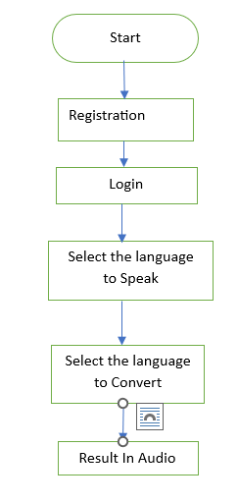

Fig 1. Block Diagram of Proposed System

4. REQUIREMENT ANALYSIS
4.1 Functional and non-functional requirements
Requirement’s analysis is very critical process that enables the success of a system or software project to be assessed. Requirements are generally split into two types: Functional and non-functional requirements.
Functional Requirements: These are the requirements that the end user specifically demands as basic facilities that the system should offer. All these functionalities need to be necessarily incorporated into the system as a part of the contract. These are represented or stated in the form of input to be given to the system, the operation performed and the output expected. They are basically the requirements stated by the user which one can see directly in the final product, unlike the non-functional requirements.
Examples of functional requirements:
- Authentication of user whenever he/she logs into the system
- System shutdown in Medical Insurance Cost.
- A verification email is sent to user whenever he/she register for the first time on some software system.
Non-functional requirements: These are basically the quality constraints that the system must satisfy according to the project contract. The priority or extent to which these factors are implemented varies from one project to other. They are also called non-behavioral requirements.
They basically deal with issues like:
- Portability
- Security
- Maintainability
- Reliability
- Scalability
- Performance
- Reusability
- Flexibility
Examples of non-functional requirements:
- Emails should be sent with a latency of no greater than 12 hours from such an activity.
- The processing of each request should be done within 10 seconds
- The site should load in 3 seconds whenever of simultaneous users are > 10000
  - Hardware Requirements

Processor - I5/Intel Processor
Hard Disk - 160GB
Key Board - Standard Windows Keyboard
Mouse - Two or Three Button Mouse
Monitor -Any
RAM - 8GB
  - Software Requirements:
Operating System : Windows 7/8/10
Server side Script : HTML, CSS, Bootstrap & JS
Programming Language : Python
Libraries : Flask, Pandas, Mysql.connector, Os, Smtplib, Numpy
IDE/Workbench : PyCharm, VScode, Jupyter NoteBook
Technology : Python 3.6+
Server Deployment : Xampp Server
Database : MySQL

  - Architecture:

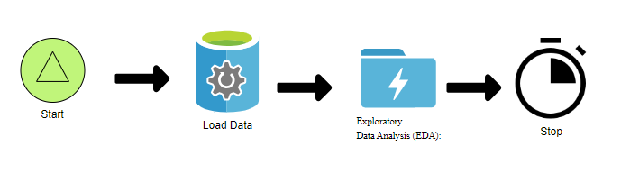

5. SYSTEM DESIGN
5.1 Introduction of Input Design:
In an information system, input is the raw data that is processed to produce output. During the input design, the developers must consider the input devices such as PC, MICR, OMR, etc.
Therefore, the quality of system input determines the quality of system output. Well-designed input forms and screens have following properties −
- It should serve specific purpose effectively such as storing, recording, and retrieving the information.
- It ensures proper completion with accuracy.
- It should be easy to fill and straightforward.
- It should focus on user’s attention, consistency, and simplicity.
- All these objectives are obtained using the knowledge of basic design principles regarding −
  - What are the inputs needed for the system?
  - How end users respond to different elements of forms and screens.

Objectives for Input Design:
The objectives of input design are −
- To design data entry and input procedures
- To reduce input volume
- To design source documents for data capture or devise other data capture methods
- To design input data records, data entry screens, user interface screens, etc.
- To use validation checks and develop effective input controls.

Output Design:
The design of output is the most important task of any system. During output design, developers identify the type of outputs needed, and consider the necessary output controls and prototype report layouts.

Objectives of Output Design:
The objectives of input design are:
- To develop output design that serves the intended purpose and eliminates the production of unwanted output.
- To develop the output design that meets the end user’s requirements.
- To deliver the appropriate quantity of output.
- To form the output in appropriate format and direct it to the right person.
- To make the output available on time for making good decisions.
5.2 UML Diagrams:
UML stands for Unified Modelling Language. UML is a standardized general-purpose modelling language in the field of object-oriented software engineering. The standard is managed, and was created by, the Object Management Group.
The goal is for UML to become a common language for creating models of object-oriented computer software. In its current form UML is comprised of two major components: a Meta-model and a notation. In the future, some form of method or process may also be added to; or associated with, UML.
The Unified Modelling Language is a standard language for specifying, Visualization, Constructing and documenting the artifacts of software system, as well as for business modelling and other non-software systems.
The UML represents a collection of best engineering practices that have proven successful in the modelling of large and complex systems.
The UML is a very important part of developing objects-oriented software and the software development process. The UML uses mostly graphical notations to express the design of software projects.

GOALS:
The Primary goals in the design of the UML are as follows:
- Provide users a ready-to-use, expressive visual modelling Language so that they can develop and exchange meaningful models.
- Provide extendibility and specialization mechanisms to extend the core concepts.
- Be independent of particular programming languages and development process.
- Provide a formal basis for understanding the modelling language.
- Encourage the growth of OO tools market.
- Support higher level development concepts such as collaborations, frameworks, patterns and components.
- Integrate best practices.
5.3 USE CASE DIAGRAM
- A use case diagram in the Unified Modeling Language (UML) is a type of behavioral diagram defined by and created from a Use-case analysis.
- Its purpose is to present a graphical overview of the functionality provided by a system in terms of actors, their goals (represented as use cases), and any dependencies between those use cases.
- The main purpose of a use case diagram is to show what system functions are performed for which actor. Roles of the actors in the system can be depicted.
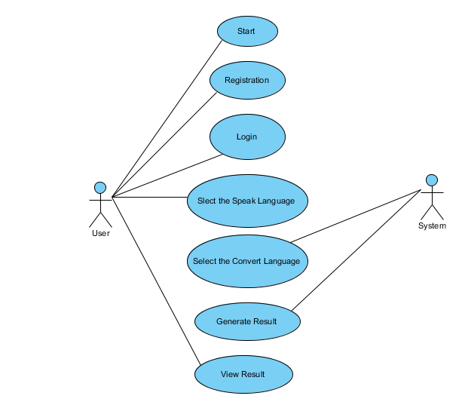

CLASS DIAGRAM
In software engineering, a class diagram in the Unified Modeling Language (UML) is a type of static structure diagram that describes the structure of a system by showing the system's classes, their attributes, operations (or methods), and the relationships among the classes. It explains which class contains information

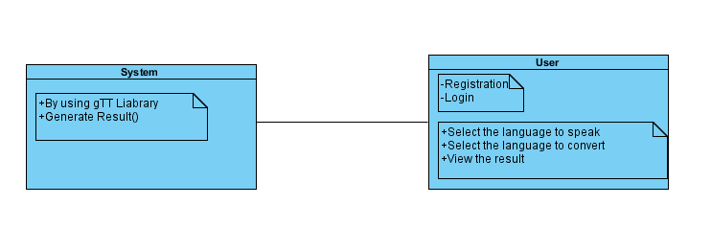

SEQUENCE DIAGRAM
- A sequence diagram in Unified Modeling Language (UML) is a kind of interaction diagram that shows how processes operate with one another and in what order.
- It is a construct of a Message Sequence Chart. Sequence diagrams are sometimes called event diagrams, event scenarios, and timing diagrams
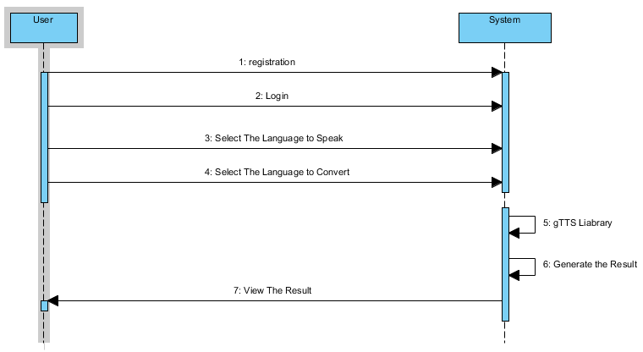

COLLABORATION DIAGRAM:
In collaboration diagram the method call sequence is indicated by some numbering technique as shown below. The number indicates how the methods are called one after another. We have taken the same order management system to describe the collaboration diagram. The method calls are similar to that of a sequence diagram. But the difference is that the sequence diagram does not describe the object organization whereas the collaboration diagram shows the object organization.
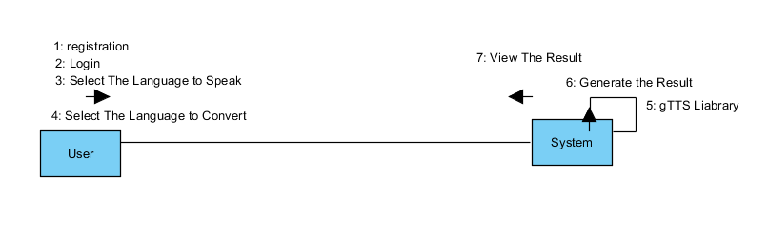

DEPLOYMENT DIAGRAM
Deployment diagram represents the deployment view of a system. It is related to the component diagram. Because the components are deployed using the deployment diagrams. A deployment diagram consists of nodes. Nodes are nothing but physical hardware’s used to deploy the application.
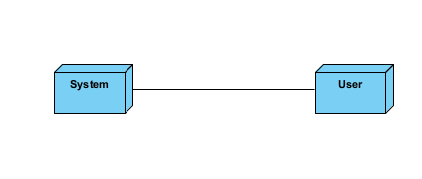
ACTIVITY DIAGRAM:
Activity diagrams are graphical representations of workflows of stepwise activities and actions with support for choice, iteration and concurrency. In the Unified Modeling Language, activity diagrams can be used to describe the business and operational step-by-step workflows of components in a system. An activity diagram shows the overall flow of control.
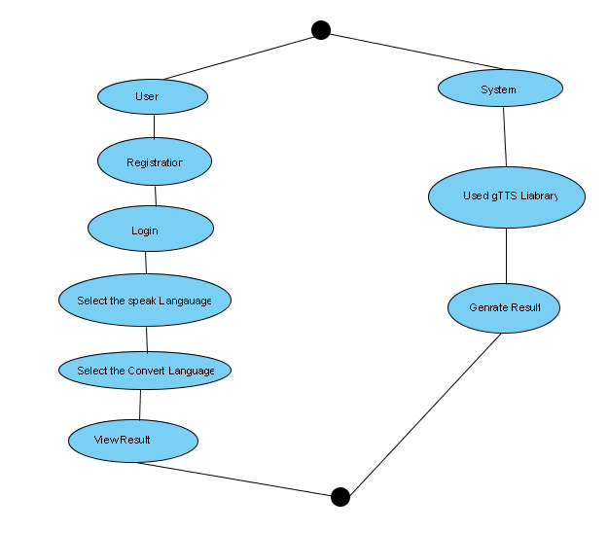

COMPONENT DIAGRAM:
A component diagram, also known as a UML component diagram, describes the organization and wiring of the physical components in a system. Component diagrams are often drawn to help model implementation details and double-check that every aspect of the system's required function is covered by planned development.
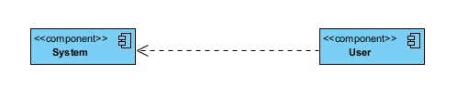
ER DIAGRAM:
An Entity–relationship model (ER model) describes the structure of a database with the help of a diagram, which is known as Entity Relationship Diagram (ER Diagram). An ER model is a design or blueprint of a database that can later be implemented as a database. The main components of E-R model are: entity set and relationship set.
An ER diagram shows the relationship among entity sets. An entity set is a group of similar entities and these entities can have attributes. In terms of DBMS, an entity is a table or attribute of a table in database, so by showing relationship among tables and their attributes, ER diagram shows the complete logical structure of a database. Let’s have a look at a simple ER diagram to understand this concept.

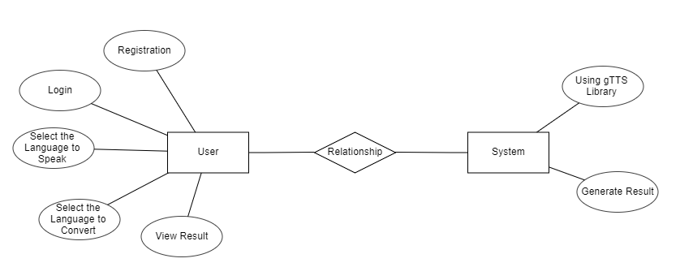

DFD DIAGRAM:
A Data Flow Diagram (DFD) is a traditional way to visualize the information flows within a system. A neat and clear DFD can depict a good amount of the system requirements graphically. It can be manual, automated, or a combination of both. It shows how information enters and leaves the system, what changes the information and where information is stored. The purpose of a DFD is to show the scope and boundaries of a system as a whole. It may be used as a communications tool between a systems analyst and any person who plays a part in the system that acts as the starting point for redesigning a system.

Contrast Level:
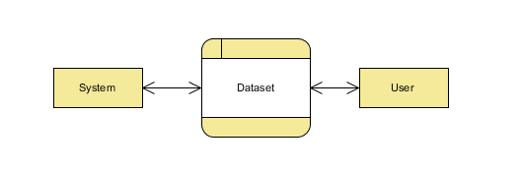
Level 1:
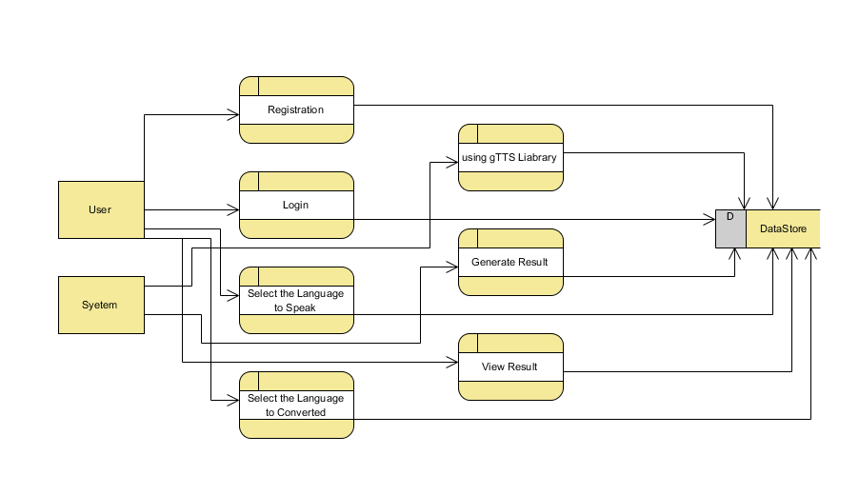

Level 2:
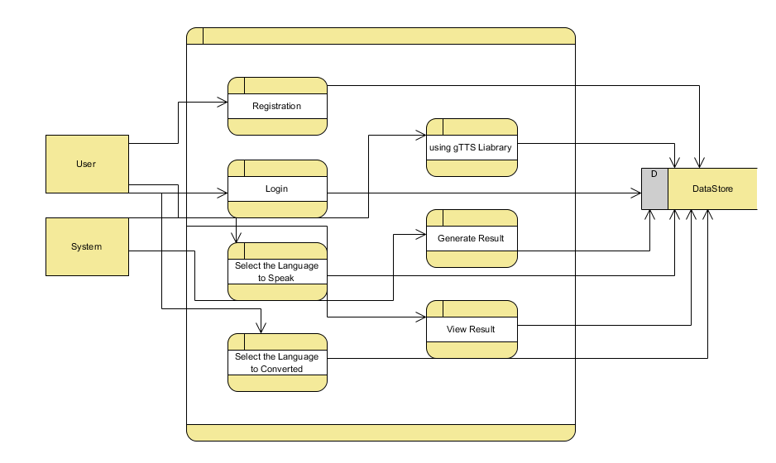

6. IMPLEMENTATION AND RESULTS
- User:
  - Input Model:
The user must provide input values for the certain fields in order to get results.
  - View Results:
User view’s the generated results from the model.

- System
  - Pre-processing:
Data need to be pre-processed according the gTTS Liabrary.
  - Generated Score:
Here generate the result

ALGORITHMS

gTTS (Google Text-to-Speech): gTTS (Google Text-to-Speech) is a Python library that converts text to speech using Google's TTS API. It allows users to generate spoken audio from text in various languages and accents. The library provides easy-to-use functions for text-to-speech conversion, offering customization options such as language selection, speed adjustment, and output file formats. gTTS is widely used for automating speech synthesis tasks, creating audio versions of text content for accessibility purposes, and building voice-enabled applications. With its simplicity and integration with Google's TTS service, gTTS remains a popular choice for developers seeking efficient text-to-speech solutions in Python.

6.2 Output Screens
Home Page: User can view the Home page.
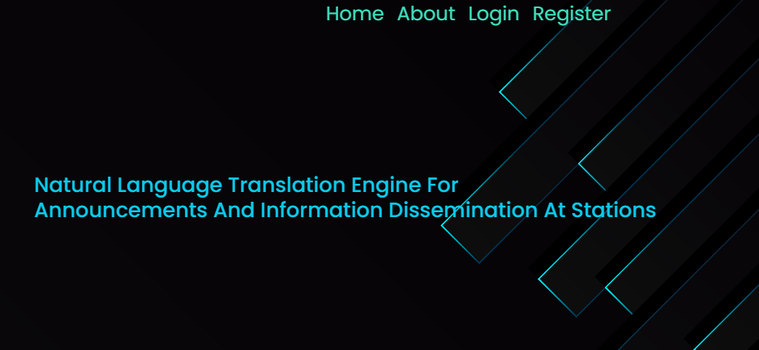
Fig2: Home Page

About: This is The small information about project
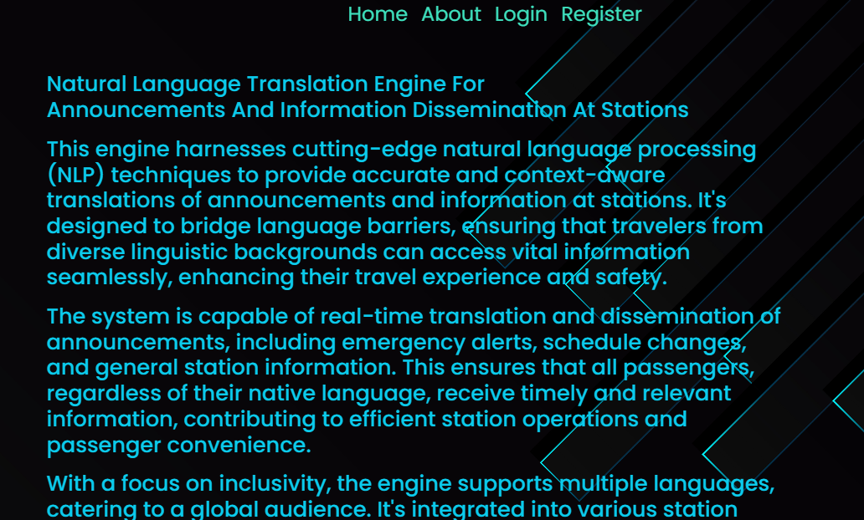
Fig3: About Page.
User Registration page: User can register with required details.
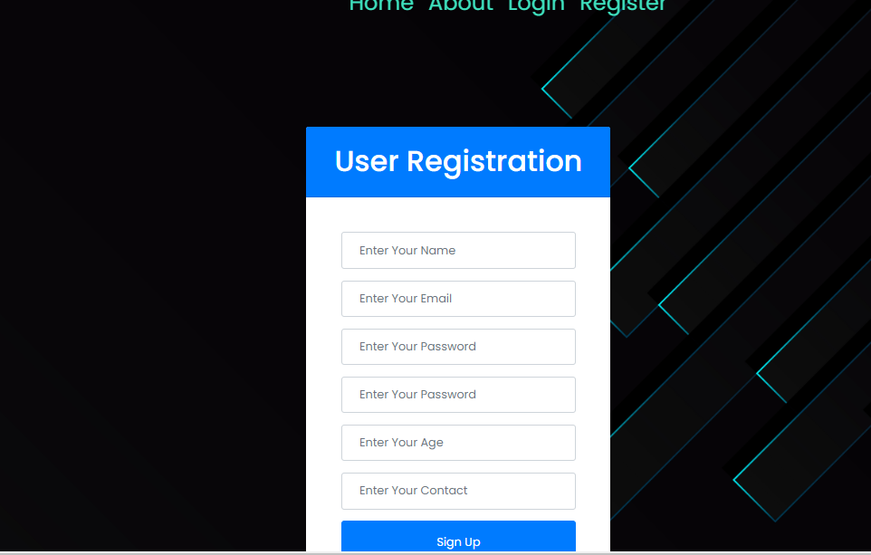

User Login: User can login with valid credentials.

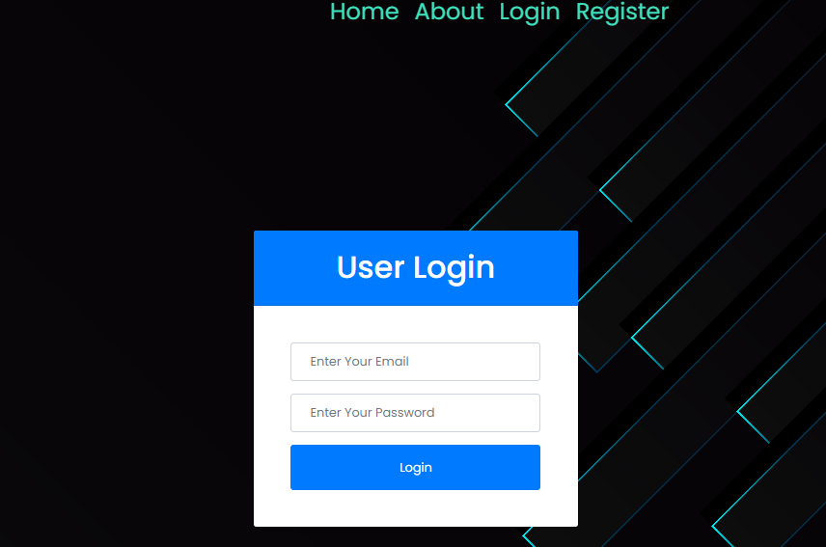

User Home page: User can view the home page after successful login.
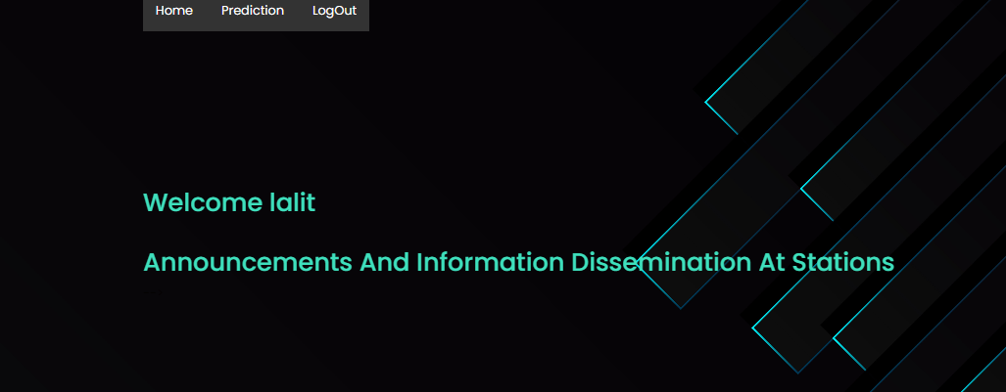

Prediction: User can give a input and view The Predicted Result
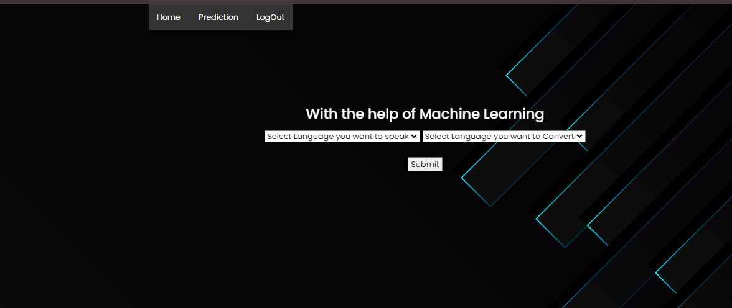

Fig6: Prediction Page.

7. SYSTEM STUDY AND TESTING
7.1 System Testing
The purpose of testing is to discover errors. Testing is the process of trying to discover every conceivable fault or weakness in a work product. It provides a way to check the functionality of components, sub-assemblies, assemblies and/or a finished product It is the process of exercising software with the intent of ensuring that the
Software system meets its requirements and user expectations and does not fail in an unacceptable manner. There are various types of test. Each test type addresses a specific testing requirement.

7.2 Types of Tests

7.2.1 Unit testing
Unit testing involves the design of test cases that validate that the internal program logic is functioning properly, and that program inputs produce valid outputs. All decision branches and internal code flow should be validated. It is the testing of individual software units of the application .it is done after the completion of an individual unit before integration. This is a structural testing, that relies on knowledge of its construction and is invasive. Unit tests perform basic tests at component level and test a specific business process, application, and/or system configuration. Unit tests ensure that each unique path of a business process performs accurately to the documented specifications and contains clearly defined inputs and expected results.

7.2.2 Integration testing
Integration tests are designed to test integrated software components to determine if they actually run as one program. Testing is event driven and is more concerned with the basic outcome of screens or fields. Integration tests demonstrate that although the components were individually satisfaction, as shown by successfully unit testing, the combination of components is correct and consistent. Integration testing is specifically aimed at exposing the problems that arise from the combination of components.
Software integration testing is the incremental integration testing of two or more integrated software components on a single platform to produce failures caused by interface defects.
The task of the integration test is to check that components or software applications, e.g. components in a software system or – one step up – software applications at the company level – interact without error.
Test Results: All the test cases mentioned above passed successfully. No defects encountered.

Acceptance Testing
User Acceptance Testing is a critical phase of any project and requires significant participation by the end user. It also ensures that the system meets the functional requirements.
Test Results: All the test cases mentioned above passed successfully. No defects encountered.

7.2.3 Functional testing
Functional tests provide systematic demonstrations that functions tested are available as specified by the business and technical requirements, system documentation, and user manuals.
Functional testing is centered on the following items:
Valid Input : identified classes of valid input must be accepted.
Invalid Input : identified classes of invalid input must be rejected.
Functions : identified functions must be exercised.
Output : identified classes of application outputs must be exercised.
Systems/Procedures: interfacing systems or procedures must be invoked.
Organization and preparation of functional tests is focused on requirements, key functions, or special test cases. In addition, systematic coverage pertaining to identify Business process flows; data fields, predefined processes, and successive processes must be considered for testing. Before functional testing is complete, additional tests are identified and the effective value of current tests is determined.

7.2.4 White Box Testing
White Box Testing is a testing in which in which the software tester has knowledge of the inner workings, structure and language of the software, or at least its purpose. It is purpose. It is used to test areas that cannot be reached from a black box level.

7.2.5 Black Box Testing
Black Box Testing is testing the software without any knowledge of the inner workings, structure or language of the module being tested. Black box tests, as most other kinds of tests, must be written from a definitive source document, such as specification or requirements document, such as specification or requirements document. It is a testing in which the software under test is treated, as a black box. you cannot “see” into it. The test provides inputs and responds to outputs without considering how the software works.
Test objectives
- All field entries must work properly.
- Pages must be activated from the identified link.
- The entry screen, messages and responses must not be delayed.
Features to be tested
- Verify that the entries are of the correct format
- No duplicate entries should be allowed
- All links should take the user to the correct page.

8.CONCLUSION
In conclusion, the integration of the Google Text-to-Speech (gTTS) Python library offers a powerful solution for enhancing communication at Indian railway stations. By converting written information into audible announcements across multiple languages and dialects, this system significantly improves accessibility and convenience for passengers. Its real-time text-to-speech conversion capability ensures dynamic and accurate information delivery, addressing the challenges of noisy environments typical in station settings. Moreover, its adaptability for mobile platforms underscores its relevance in modern railway operations. Overall, this project presents a robust tool for efficient information dissemination, aligning with the evolving needs of the Indian Railways and fostering a more inclusive travel experience.

9. FUTURE ENHANCEMENT
Future enhancements for the natural language translation engine could include integrating machine learning algorithms to improve translation accuracy and adaptability to regional dialects. Additionally, implementing voice recognition technology would enable interactive features, allowing passengers to ask questions and receive spoken responses in their preferred language. Integration with real-time data feeds could also provide up-to-date information on train schedules, delays, and platform changes, enhancing the system's utility and reliability. Furthermore, incorporating sentiment analysis could help tailor announcements to better meet passengers' needs and preferences, fostering a more personalized and user-friendly experience at railway stations.

10.REFERANCES
1. Bar-Hillel, Y. (1951). The present state of research on mechanical translation. American Documentation 2 (4): 229-237.
2. Bar-Hillel, Y. (1960). The present status of automatic translation of languages. Advances in Computers 1: 91-163.
3. Beyer, R. T. (1965). Hurdling the language barrier. Physics Today 18 (1): 46-52.
4. Birch, A., Osborne, M. (2011). Reordering metrics for MT.
5. Bisbey, R., Kay, M. (1972). The MIND translation system: a study in man-machine collaboration. Technical Report P-4786, Rand Corp.
6. Carbonell, J. (1970). AI in CAI: An artificial-intelligence approach to computer-assisted instruction. IEEE Transactions on Man-Machine Systems 11 (4): 190-202.
7. Card, S. K., Moran, T. P., Newell, A. (1983). The Psychology of Human-Computer Interaction. Lawrence Erlbaum Associates.
8. Church, K. W., Hovy, E. (1993). Good applications for crummy machine translation. Machine Translation 8: 239-258.
9. Debons, A., Cameron, W. J. (Eds.) (1975). Perspectives in Information Science, Volume 10 of the NATO Advanced Study Institutes Series. Springer.
10. Denkowski, M., Lavie, A, Lacruz, I., Dyer, C. (2014). Real time adaptive machine translation for post-editing with cdec and TransCenter. In Proceedings of the EACL 2014 Workshop on Humans and Computer-assisted Translation.
11. Engelbart, D. C. (1962). Augmenting human intellect: A conceptual framework. Technical report, SRI Summary Report AFOSR-3223.
12. Foster, G., Langlais, P., Lapalme, G. (2002). TransType: text prediction for translators. In Proceedings of ACL Demonstrations, 93-94.
13. Green, S., Wang, S., Chuang, J., Heer, J. Schuster, S., Manning, C. D. (2014). Human effort and machine learnability in computer aided translation. In Proceedings of EMNLP, 1225-1236.
14. Grudin, J. (2009). AI and HCI: Two fields divided by a common focus. AI Magazine 30 (4), 48-57.
15. Grudin, J. (2012). A moving target—the evolution of human-computer interaction. In Jacko, J. A. (Ed.), Human-Computer Interaction Handbook: Fundamentals, Evolving Technologies, and Emerging Applications (3rd edition), xxvii-lxi. CRC Press.

